Title
A. Author^{1, 2}, B. Coauthor¹
¹Institution/University, Faculty, Department, Street Name Number, Postal Code City, Country
²Institution/University, Faculty, Department, Street Name Number, Postal Code City, Country

Abstract
The abstract should not exceed more than 2 pages.
Please do not change this template since all the abstracts will be collected in the Book of Abstracts of the conference.
The text of the abstract should be Calibri with a font size of 11, black and justified.
A single figure with a caption can be included in the abstract (see Figure 1).
If you want to add bibliographic references, please write the references in plain text by including the author's last name and the year in the text (Doe et al., 2023). Add the reference in APA format in the References section below using Calibri with font size of 10.
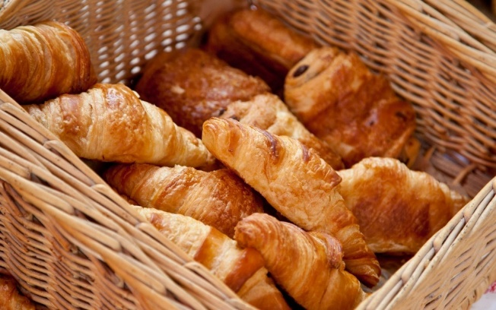
Figure 1: Typical croissant basket during a coffee break in France.

Equations
Equations should be referred to as equation (1) and all equations should be centred with equation number aligned right as the following example:
$u\left(z\right)=\frac{u_{*}}{κ} \ln\left(\frac{z}{z_{0}}\right)$ (1)
Tables
Tables should be presented in the form shown in Table 1.
Sensor | wind speed  (m/s) | wind direction  (degrees) | CO concentration  (mg/m3)
1 | 3.0 | 180 | 0.035
6 | 2.7 | 200 | 0.021
Table 1. An example of a table

Units of measurement
Please follow the SI units system of measurement. Negative indices should be used rather than "/" (e.g. ms⁻¹).

References
Doe, J. K., Windy, A. R., & Tornado, C. D. (2023). Blowing Away the Competition: A Study on the Aerodynamic Properties of Cheese Puffs in Wind Tunnels. Building and Destroying, 42. 100-200.

